Racial Equity Audit: Keep Cincinnati Beautiful

Katie Nolan
Public Sector Human Resource Management
Dr. Tia Sheree Gaynor
April 29, 2022

Introduction
Public and nonprofit organizations must prioritize racial equity. In America, the systems that make up society are inherently rooted in racism. Non-private organizations serve people and causes that are focused on making a positive difference. Racial Equity Audits are a way for organizations to self-identify problem areas in their own organization that perpetuate structurally racist systems, and learn what they can do to improve. Cincinnati, Ohio, is the fifth most segregated city in America, (Kent, Frohlich). It is crucial that organizations across the city work diligently to reduce racial inequities and correct racial injustices as much as possible.
Keep Cincinnati Beautiful, (KCB), is a nonprofit organization, founded in 1978. Their mission is to empower Cincinnati residents to “build community and create a positive future through revitalization, education, and mobilization,” (Keep Cincinnati Beautiful). KCB provides a variety of programs, including art projects, greenspace creation, neighborhood cleanups, environmental services, and environmental education. They are a cornerstone in the Cincinnati nonprofit community, and they do amazing work for the city. They are an eight-person team, none of these team members identifying as people of color. For this racial equity audit, I was able to speak with 5 members of the staff.
When speaking with staff members of KCB, it is evident that their hiring process, as well as the recruitment, retention, and promotion of people of color, do not directly address racial and ethnic inequities. Additionally, there is a lack of racial equity and cultural competency training within the organization. However, it is also evident that the entire staff are willing to address these inequities and discover ways to correct them. Through a Racial Equity Audit, this paper addresses the racial inequities in KCB’s hiring process, training process, as well as their internal culture, to further improve KCB’s service to the city of Cincinnati and their ability to connect further with the diverse community that it holds.
Interview Data
Using qualitative analysis of interview data, racial inequities are identified. Using the “Tool for Organizational Self-Assessment Related to Racial Equity,” by the Eliminating Disparities in Child & Youth Success Collaborative, and the Coalition of Communities of Color, staff of KCB were asked to rank their performance on several organizational characteristics and workforce competencies, (Section One). Rankings were as follows: 1 = Haven’t started work in this area yet. 2 = Plans exist to use in planning and implementation. 3 = This is in place, and we have evidence of its use. 4 = This is part of our routine, and we model it for others. In the second section, staffers were asked Yes or No questions about KCB’s organizational structure and racial equity, (Section Two). Results for Section One are represented in Figure 3. Organizational characteristics that are ranked lower on the scale, revealed problem areas for the organization. Organizational characteristics with higher rankings showed the organization’s strengths.
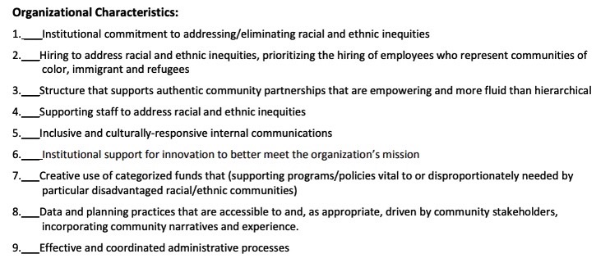
Figure 1: Section 1 Statements
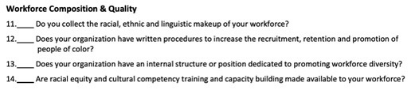
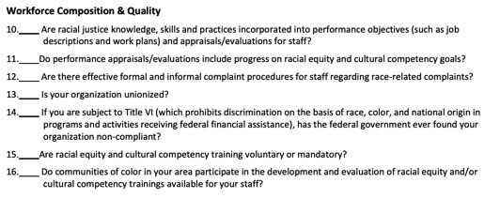
Figure 2: Section 2 Competencies

Figure 3: Data for Section 1

Strengths
In Section One, KCB’s strengths lied in the characteristics that were, on average, ranked a “3” or higher. These strengths are listed below with their calculated average ranking:
- Structure that supports authentic community partnerships that are empowering and more fluid than hierarchal, (3.6).
- Inclusive and culturally responsive internal communications, (3.3).
- Institutional support for innovation to better meet the organization’s mission, (3.2).
- Creative use of categorized funds that support programs vital to racial or ethnic communities, (3.4).
- Data and planning practices that are accessible to, and as appropriate, driven by community stakeholders, incorporating community narratives and experience, (3.2).
Section One determines that KCB’s strengths lie in their fluid community partnerships, as well as their inclusive communications and workplace culture. KCB’s intentions are in the right place for a racial equity audit, and their staff are committed to bettering their organization and prioritizing racial equity in their policies and practices. However, no characteristic in Section One was labeled a “4” by the staff. Never achieving the highest ranking in these categories suggests that there is room for improvement concerning racial equity across the board at KCB. In Section Two, the strengths of KCB were determined when staffers mainly answered “Yes” to the following questions:
- Do you collect the racial, ethnic, and linguistic makeup of your workforce?
- Does your organization have written procedures to increase the recruitment, retention, and promotion of people of color?
- Are racial equity and cultural competency training and capacity building made available to your workforce?
- Are there effective formal and informal complaint procedures for staff regarding race-related complaints?
Section Two’s results suggest that KCB feels confident in their more structured, written policy regarding racial equity in general as an organization. As an organization, they are committed to serving communities of color in Cincinnati, and they are aware of their diverse service base. Their weaknesses lie more in their hiring, recruitment, retention, and promotion of people of color, as well as training practices.

Gaps (Problem Areas)
A few characteristics of the organization were ranked less than “3.” These characteristics are listed below, with a calculated average of their rankings.
- Institutional commitment to addressing/eliminating racial and ethnic inequities (2.5)
- Hiring to address racial and ethnic inequities, prioritizing the hiring of employees who represent communities of color, immigrant, and refugees (1.6)
- Supporting staff to address racial and ethnic inequities (2.4)
- Effective and coordinated administrative processes (2.8)
Section One’s results identify that some of KCB’s main problem areas include the hiring process, as well as some administrative processes. In Section Two, gaps were recognized when these questions were answered “No” by KCB staff.
- Does your organization have an internal structure or position dedicated to promoting workforce diversity?
- Are racial justice knowledge, skills, and practices incorporated into performance objectives (such as job descriptions and work plans) and appraisals/evaluations for staff?
- Are racial equity and cultural competency training mandatory?
- Do communities of color in your area participate in the development and evaluation of racial equity and/or cultural competency trainings available for your staff?
Additionally, respondents had the opportunity to speak directly about what problems they have noticed regarding racial equity and HR practices, and they openly told me about what they hoped this racial equity audit could help them with. In these conversations, a common answer was their struggle with hiring and retaining applicants of color.
Immediately noticeable is the need to address the lowest-ranked competency in the list, which is the diversity in their hiring process. Connected to this is the lack of racial justice knowledge, skills, and practices located in job descriptions and work plans. Another larger issue is that KCB’s diversity, equity, and inclusion training is not mandatory for employees, nor is the creation of this training centered around Cincinnati’s communities of color, (there was also a discrepancy in answers for this section – some employees did know that DEI training was available to them, and some did not). Additionally, having an internal structure promoting diversity would help to accomplish all these goals.

Solutions for an equitable organization
Hiring
It is evident that the biggest equity-related concern with KCB and its staff is rooted in their hiring process. This was the organization’s lowest rated competency overall, and staff actively expressed interest in improving this area of the organization. A few members of KCB suggested that the organization’s hiring and retention has not been diverse because of Maslow’s hierarchy of needs. While this is a generalized assumption about communities of color, their staffing reflects that they may not have had many applicants of color when job positions have been open. One team member stated that their staff is “very white” but that they are actively searching for ways to diversify their team so that it reflects the makeup of Cincinnati and the communities they serve.
To prioritize the hiring of minority individuals, KCB should establish a comprehensive hiring process that involves bias-checking. Bias training should be implemented into the mandatory racial equity training, so that all employees can understand bias and how it can be checked to ensure diverse hiring and retention. This audit also suggests that intentionally writing job descriptions will be beneficial to the organization. Include professional development and advancement opportunities in the job description to ensure that applicants of color do not feel like they would be considered for a job to fulfill a diversity mission or quota. Emphasizing the organization’s genuine prioritization of the promotion of employees of color will encourage applicants of all backgrounds to apply.
Additionally, KCB’s networking with other organizations that are led by employees of color will also be crucial in this process. By consulting with these organizations, as well as promoting job opportunities through organizations that focus on the empowerment and advancement of communities of color, diversity and racial equity can be more of a priority. Below is a list of examples of organizations dedicated to connecting applicants of color with environmental jobs:
- MobilizeGreen
- Brown Girl Green’s Jobs Board
- Generation Green
- Intersectional Environmentalist
One of the most evident improvements needed at KCB is prioritizing equity, diversity, and inclusion in their hiring and retention process. When serving communities of color as KCB does, it is essential to have team members that reflect that population. Ensuring a more diverse team will improve KCB’s ability to better serve the Cincinnati community.

Centering racial equity in mandatory staff training
A first step towards racial equity in KCB is prioritizing a mandatory racial equity training for all employees. To create true racial equity in an organization, there must be mandatory equity training. When employees can choose to opt out of racial equity training, they miss out on equity education that can leave gaps in workplace culture and equity. By taking this step, it can be ensured that racial equity communication is streamlined across the organization and that all employees are educated on the importance of racial equity throughout every facet of the organization. This racial equity audit suggests a greater need to connect with communities of color in Cincinnati, as well as bolstering KCB’s racial equity training. By consulting with organizations local to Cincinnati that are led by people of color that specialize in diversity, equity, and inclusion training, KCB can both create a strong network with organizations that prioritize equity, and further connect with the Cincinnati community.

Creating a racial equity team within the KCB staff
By creating a racial equity team or committee within existing KCB staff, racial equity goal setting can take place. This will also ensure that the other goals described in the equity plan will be adhered to and accomplished. Using the racial equity committee suggested previously, all goals set in the racial equity plan can be reviewed, built upon, and utilized through this team. Having a racial equity team within KCB’s staff would be responsible for tracking progress of equitable goals for the whole team. Individual equity goals will also be included in the team’s employee evaluations and goal setting. It is also crucial to note that these team members should be compensated for the extra work they would put into this racial equity work.
Creating a committee, taskforce, or racial equity team that will focus on the implementation and evaluation of each of these equity goals is essential to ensure accountability within the KCB team. This team will also be essential in creating new equity goals as the KCB team moves forward.

Conclusion
This racial equity audit seeks to improve KCB’s overall workplace culture, as well as specific Human Resources processes that can be improved through direct action from the KCB team. One of KCB’s biggest concerns is the overall lack of diversity within their team. This audit also determined that racial equity can be further sought through mandatory racial equity training, networking with local organizations that prioritize racial equity and are led by people of color and creating a racial equity committee to ensure all these goals are met. Keep Cincinnati Beautiful has done great work for the environment and communities of Cincinnati. By consulting with and sticking to this racial equity plan, their racial equity goals can be met, and they will be better equipped to serve all Cincinnatians.

Works Cited
About us: Mission and vision. Keep Cincinnati Beautiful, Inc. (n.d.). Retrieved March 13, 2022, from https://www.keepcincinnatibeautiful.org/about-us/mission-and-vision.html
Kent, A., & Frohlich, T. C. (2016, June 20). Cincinnati is the 5th most segregated city in America. Cincinnati Stats. Retrieved March 13, 2022, from https://cincinnatistats.com/cincinnati-is-the-5th-most-segregated-city-in-america/#:~:text=In%20the%20Cincinnati%20area%2C%2074.1,group%20lived%20with%20each%20other. `
Rubio, C., Morse, C., Deloney, G., & Cha, L. P. (2014, January). Tool for Organizational Self-Assessment Related to Racial Equity. Regional Arts and Culture Council. Retrieved March 13, 2022, from https://racc.org/wp-content/uploads/buildingblocks/foundation/CCC%20-%20Tool%20for%20Organizational%20Self-Assessment%20Related%20to%20Racial%20Equity.pdf

