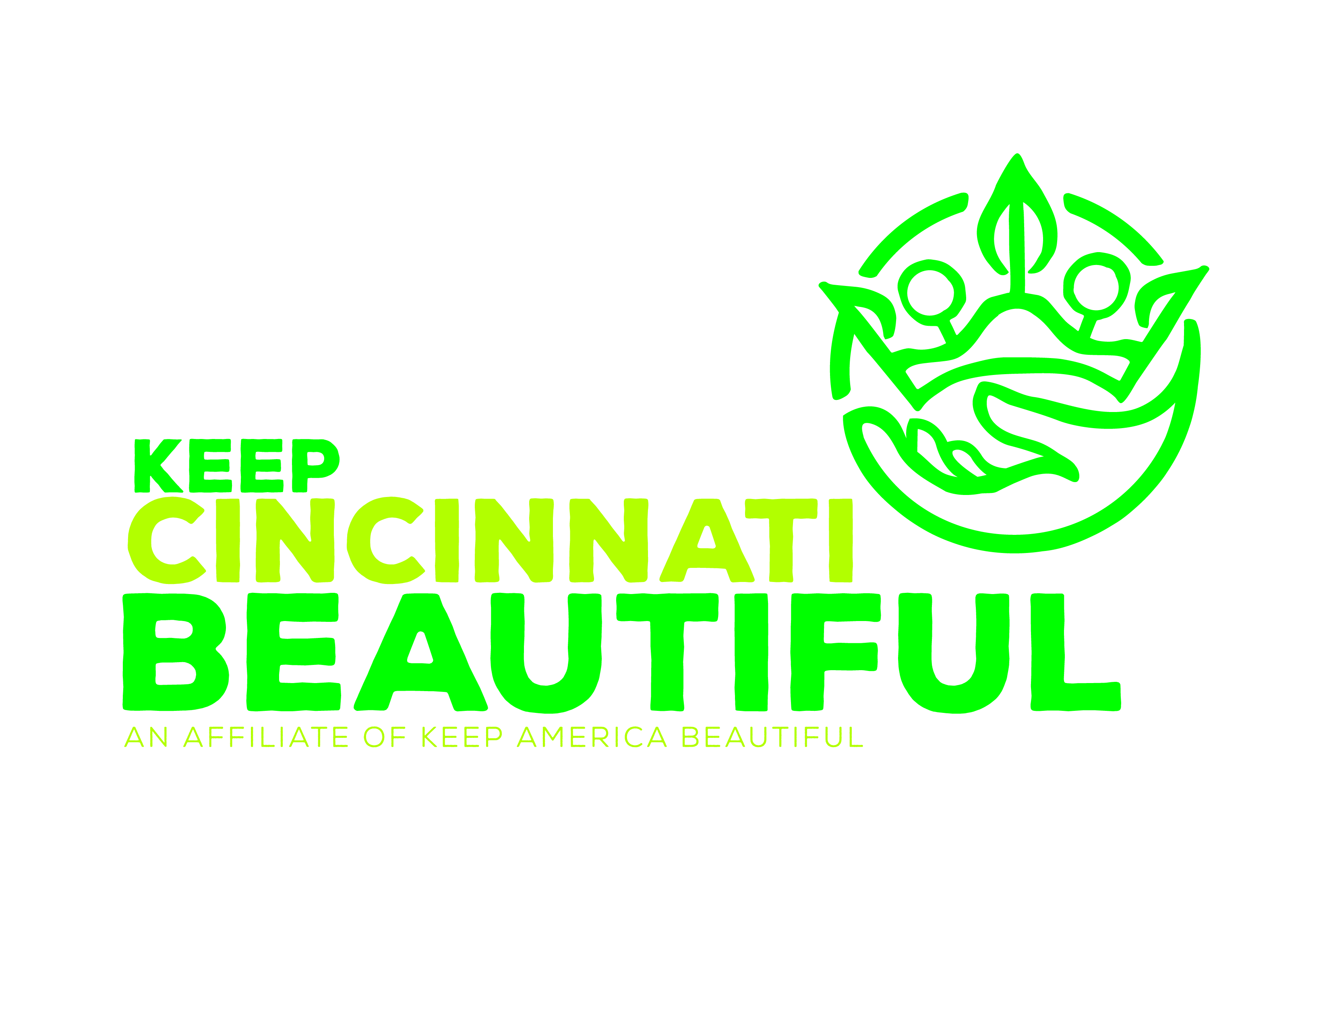 For Immediate Release
If you have a logo, place it here!
Add Your Logo Here
Contact:
Megan Beck (513) 352-4385

Help Avondale Stay Clean, Safe, and Strong During This Year’s Great American Cleanup
Volunteer With Your Neighbors to Clean Streets, Parks, and Business Districts on Saturday, April 7

WHAT: The Avondale Community Council is seeking volunteers to help pick up litter, clean parks and recreation areas, paint blighted buildings, and remove graffiti during the 2014 Great American Cleanup. The Great American Cleanup is the nation’s largest community improvement program and is organized locally by Keep Cincinnati Beautiful. Dozens of community cleanups are taking place around the city throughout the months of March through November. You can be a part of this effort by volunteering in Avondale on Saturday, April 7 from 9:00 AM to 12:00 PM. Keep Cincinnati Beautiful will be providing cleanup supplies, and we’ll provide lunch for volunteers after the cleanup. Invite your friends, family, coworkers, and neighbors and help make a difference in our community!

WHEN: Date and Time of Your Cleanup Event

WHERE: Name of Meeting Location
Address

WHO: List all participating partners, sponsors, and VIPs

###

